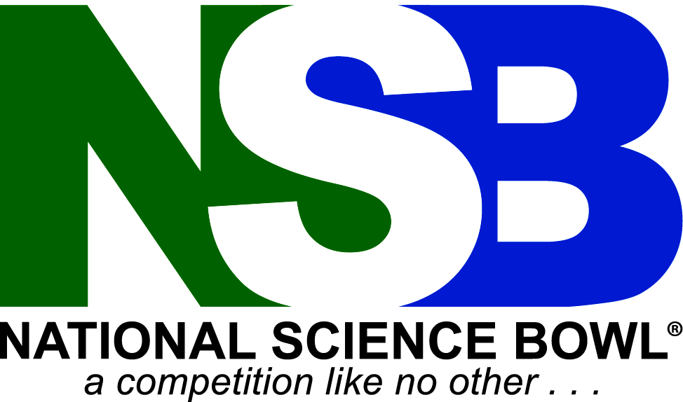

Regional Science Bowl Code of Conduct

Team members, including coaches, must conduct themselves professionally and in a manner that will bring honor to them, their school, and the competition.
- Possession or use of alcoholic beverages, illegal drugs, or any substance used as a weapon is prohibited.
- Smoking or using other tobacco products is prohibited in all buildings.
- Shirts and shoes are required inside all buildings at all times.
- Participants and coaches must respect personal and public property. Repair costs for damages incurred to property will be billed to the school responsible for such damages.

The use of electronic devices (cell phones, MP3 players, tablets, etc.) is not permitted in any competition room. If a staff member or an official sees a participant using these devices in a competition room, the device will be removed from the individual and returned at the conclusion of the event.

This is a team event, therefore one team member, coach, or team supporter, by his or her conduct, could jeopardize the entire team. If officials consider any behavior to be unsportsmanlike, such as questioning the judgment of officials, this will result in the team’s disqualification from the tournament.

I have read and will abide by the Regional Science Bowl Code of Conduct. Failure to completely adhere to the items above will result in the disqualification and expulsion of the team for the 2019 competition and may result in the disqualification of the school for the 2020 Regional Event.

Date: _______________________________

Print Student Name Student Signature

Coach Signature Parent or Guardian Signature

NOTE: Each team member, his or her parent/guardian, and coach must sign this form in order for the team to participate in the XXXXXXXXX Regional Science Bowl.

Return this completed form to:
XXXXXXXXXXXXX

