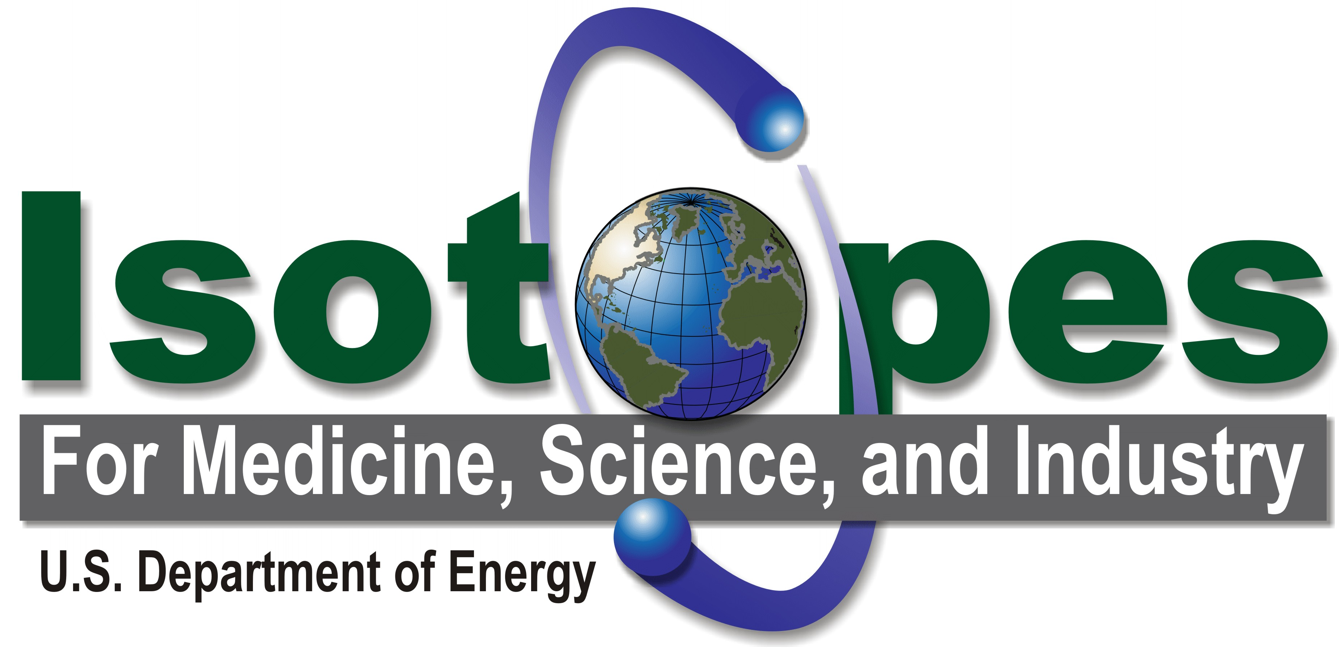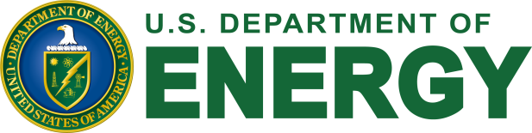

6th Workshop on Isotope Federal Supply and Demand
Thursday, November 15, 2018
Bethesda North Marriott Hotel, North Bethesda, Maryland

REGISTRATION FORM

Please return as soon as possible, but no later than November 9, 2018
Fax: 301-903-3833
E-mail to: SC.IsotopeWorkshop@science.doe.gov

NAME: ……………………………………………………………………………………

Organization: ………………………………………………………………………

ADDRESS: ………………………………………………………………………………

TEL: ……………………………………. FAX: ………………………………….

E-MAIL: …………………………………………………………………………………

SPECIAL NEEDS: ……………………………….……………………....……………

Will you be attending the Workshop on November 15, 2018?

◻ Yes
◻ No
◻ No, but I would like to receive further information about the workshop or future events.
◻ Yes, and I would be interested in making a brief presentation at the workshop about my Agency’s demand and/or supply of isotopes; or about a concern my Agency has on the supply/demand of an isotope.

Workshop Web Site: Workshop on Isotope Federal Supply and Demand

